Experiment #3 – Transistor Biasing

# Youssef Samwel, Nicolas Sayed, Brandon

# [yo800238@ucf.edu](mailto:yo800238@ucf.edu)

# EEE3307 Electronics I

Section 0014

# Due Date 10/16/2023

# **Project Description**

The objective of this experiment was to construct and analyze circuits based on diodes. The primary aim was to familiarize students with the applications of diodes and their various uses in electronic circuits.

# **2.0 About Laboratory Day and Equipment List**

# The laboratory session took place on the Monday section between 6:00pm and 8:50pm on September 25, 2023. My lab partners were Nicolas and Brandon. The equipment for the is experiment is listed below,

1. Breadboard
2. Tektronix MSO 4034 Oscilloscope
3. Tektronix AFG3022 Function Generator
4. $100µF$ Capacitor
5. $2kΩ$ Resistor
6. 1N4148 diodes x 4
7. 1N4735 or 1N5234B x 2 diodes

# **3.0 Computer Simulation (SPICE)**

# Pre-Laboratory Simulations

A) For the circuits of Fig. 1 and Fig. 2, choose available values of RL and C so that RLC = 0.2 second approximately. Draw the output waveforms when the input is sinusoidal of frequency 100 Hz and 10 V peak to peak, under the following cases:

1. Capacitor only is removed. Plot the transfer ( $V_{out}$ versus $V_{in}$) characteristics.
2. Resistor only is removed.
3. Capacitor and resistor are both in place. Calculate the peak-to-peak ripple voltage.

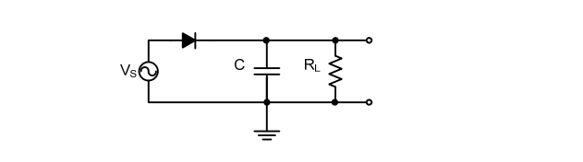

Figure 1

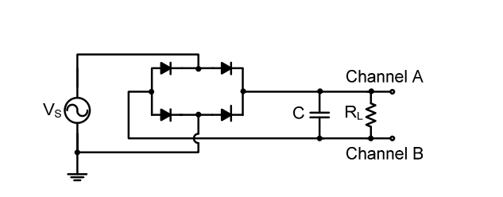

Figure 2

Waveform without Capacitor

Waveform without Resistor

Waveform with both Capacitor and Resistor

To compute the ripple voltage, we use the half-way rectifier equations, as shown below:

$$R=2kΩ;C=100µF;f=100 Hz;V_{magnitude}=5 V$$

$$V_{ripple}=\frac{V_{m}}{fRC}→\frac{5-0.7}{100*2k*100µF}$$

$$V_{ripple}=215 mV$$

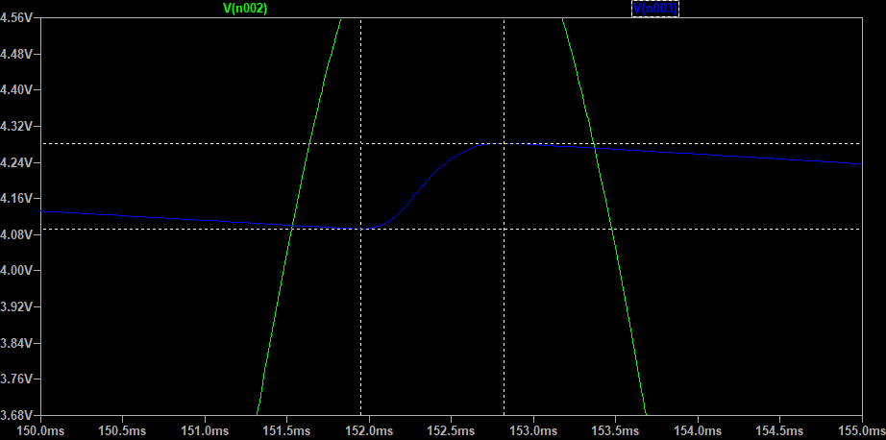The simulated ripple voltage in LT-spice is .

The difference between the simulated value and the computed value is that the equation assumes that the diode has ideal behavior, however, in the simulation, LT-spice accounts for diode non-ideal parameters.

B) Determine the transfer characteristics of the circuits in Fig. 3 and Fig. 4. Draw the output waveforms assuming that the input is a sinusoid with sufficiently larger amplitude (larger than both reference voltages or the Zener voltages) amplitude.

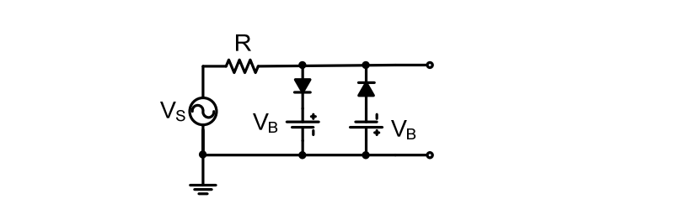

Figure

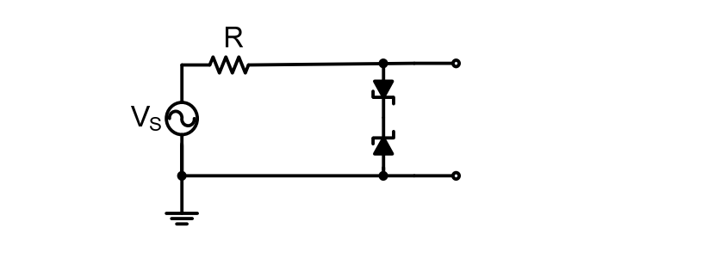

Figure

Input vs Output Voltage for Fig. 3

For $V_{b}$ we used $1.5 V$ and the resistance value was .

Input vs Output Voltage for Fig. 4

The breakdown voltage for the Zener diodes in the simulation is $6.2 V$ which is similar to the diode used in the experiment.

C) For the circuit shown in Fig. 5, draw the output waveform if the input is a sinusoid. Do not neglect the diode turn on voltage (≈ 0.65 V). Select available values of R and C so that RC time constant is equal to 0.2 seconds approximately (e.g., for a capacitor of 10 µF, the resistor value should be 20 kΩ).

Figure 5

Input vs Output Voltage for Fig. 5

$R=2kΩ;C=100µF;f=100 Hz;V_{pp}=10 V$

# **4.0 Experiment Procedure**

# Full Wave Rectifier Circuit

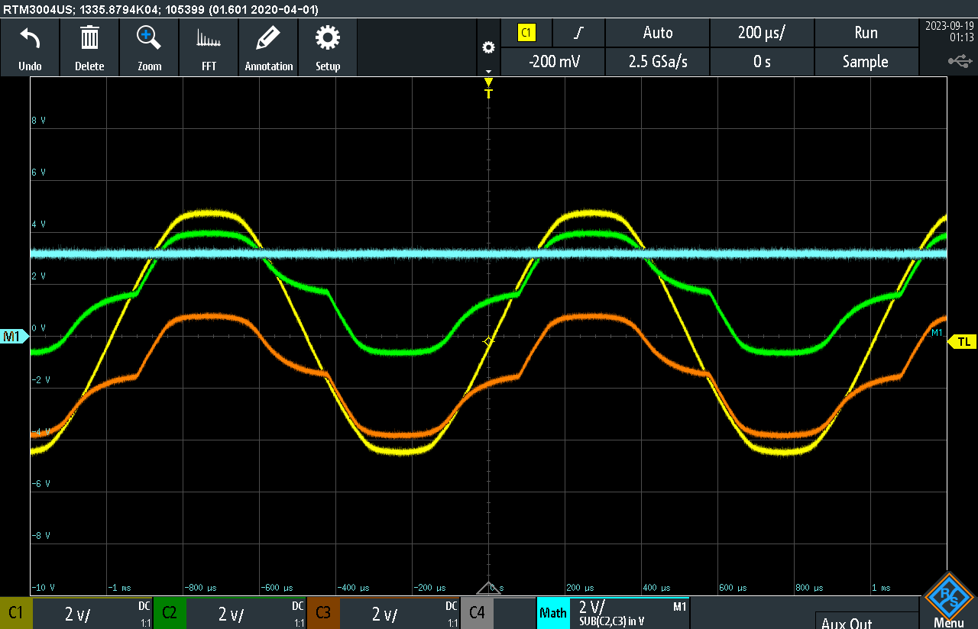

Sine Wave Input vs Differential Output

Square Wave Input vs Differential Output

Triangle Wave Input vs Differential Output

# Clipping Circuits

a) Connect the circuit in Fig. 3. Let the input be a sinusoid of frequency 1 kHz. Display the input and output waveforms on the oscilloscope. Vary the amplitude of the input and observe the result. Display the $V_{out}$ vs. $V_{in}$ transfer characteristics of the circuit on the oscilloscope. Change the input waveform to a triangular or square waveform and see what happens.

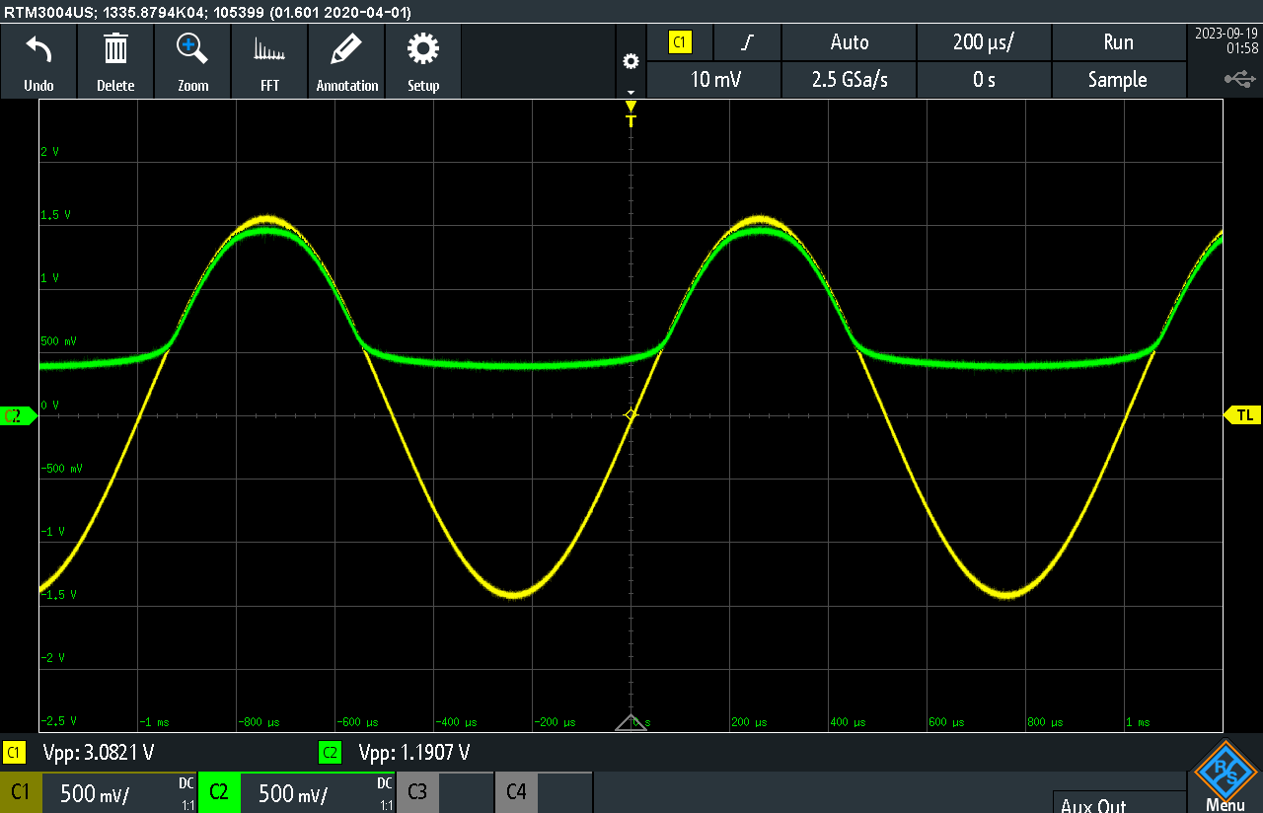

$V_{out}$ vs. $V_{in}$ when Vb = 0

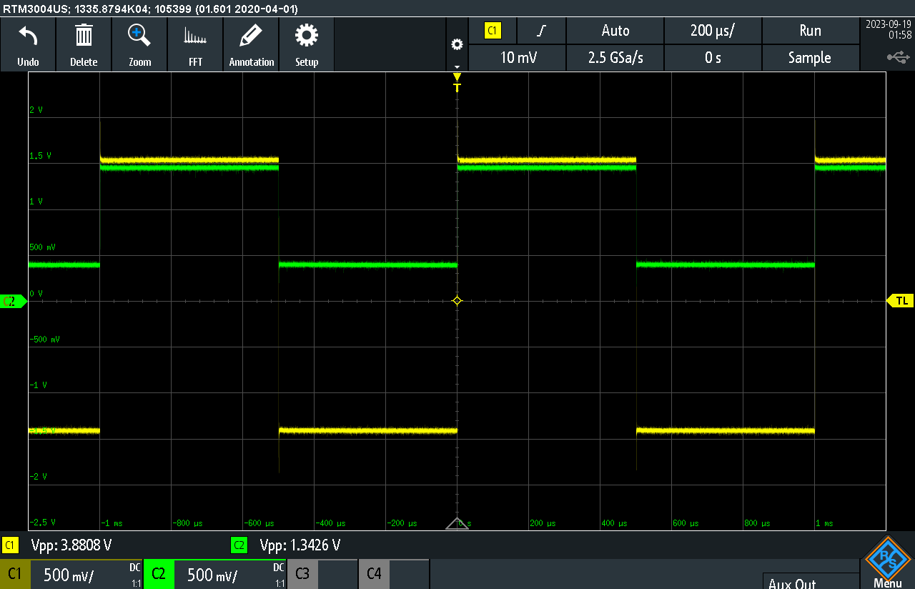

$V_{out}$ vs. $V_{in}$ when Vb = 0

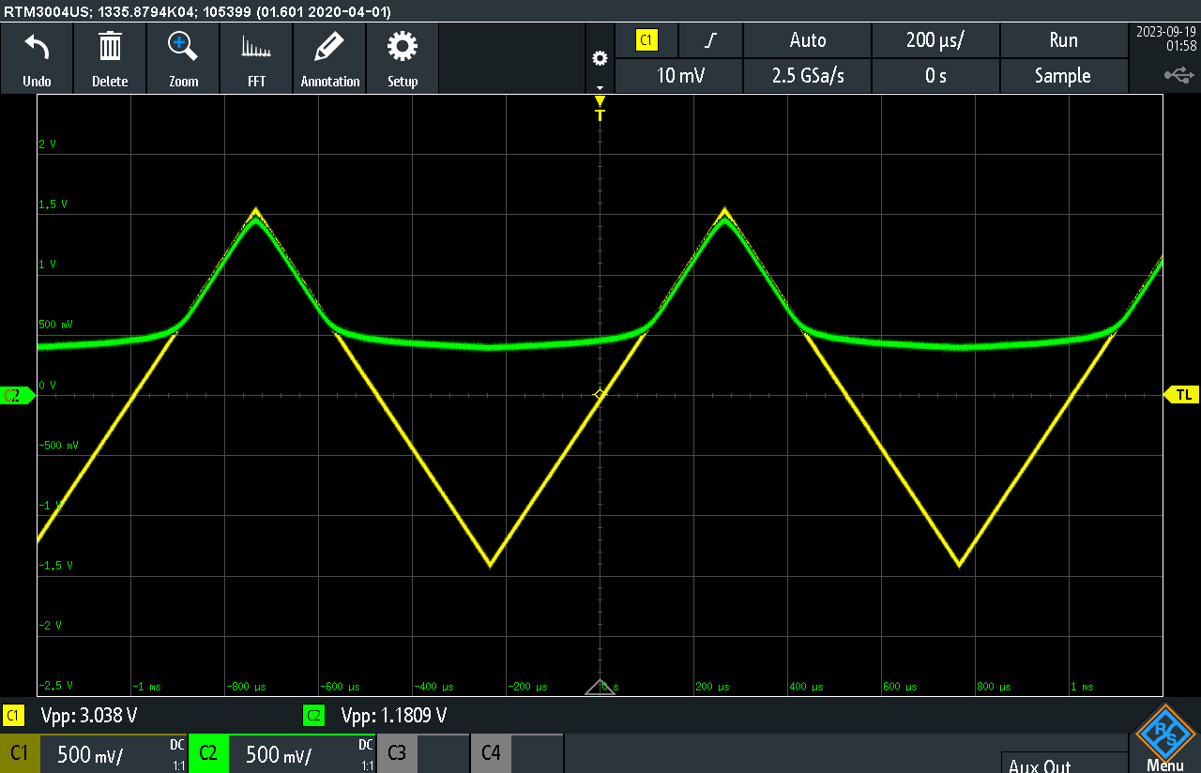

$V_{out}$ vs. $V_{in}$ when Vb = 0

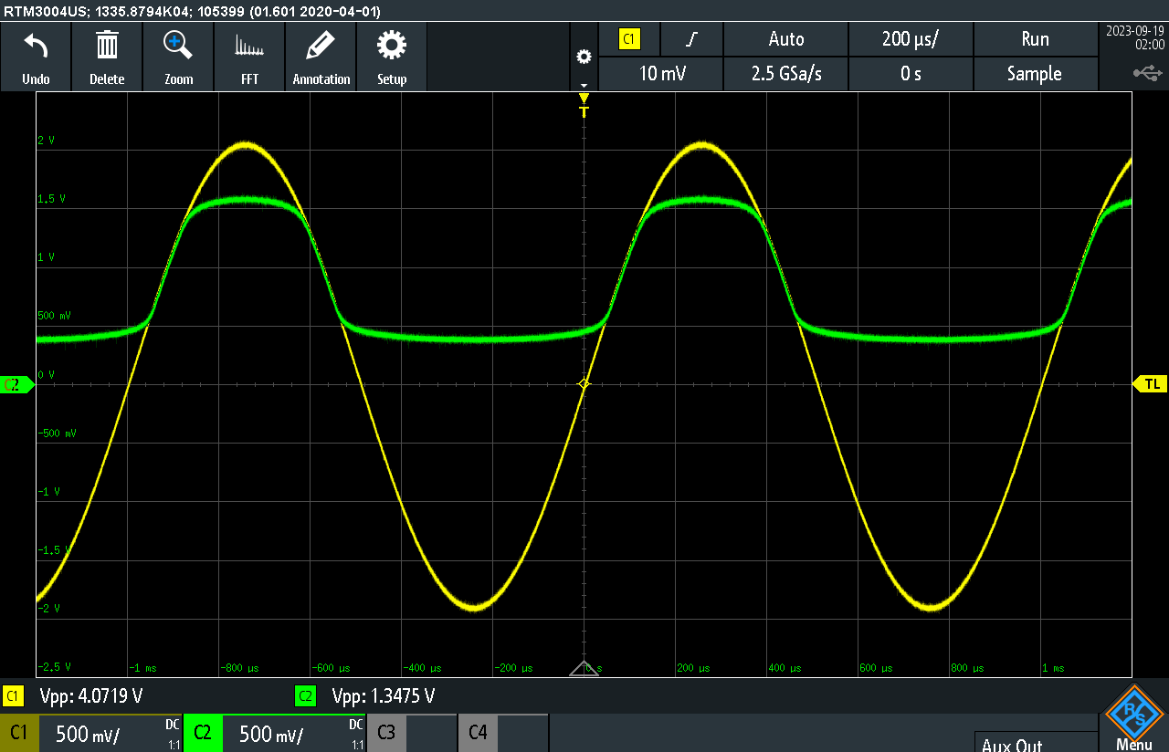

$V_{out}$ vs. $V_{in}$ with variable

vs. with variable

vs. with variable $V_{in}$

b) Repeat the same steps for the circuit in Fig. 4. Note that the Zener breakdown voltage of 1N5234 is about -6.2 V and Zener diode’s forward turn-on voltage is about 0.65 V. Your input voltage may change to 20 V peak to peak to provide sufficiently larger amplitude.

# Clamping Circuits

a) Connect the circuit in Fig. 5. Let the input be a sinusoid of any amplitude at 1 kHz. While observing the output waveform (set the oscilloscope scope to be DC coupled), vary the amplitude of the input and observe the result. Next, leave the amplitude the same and add a DC offset in the input (There should be an “offset” control on the generator) and again observe the output. Make comments.

Sine Wave

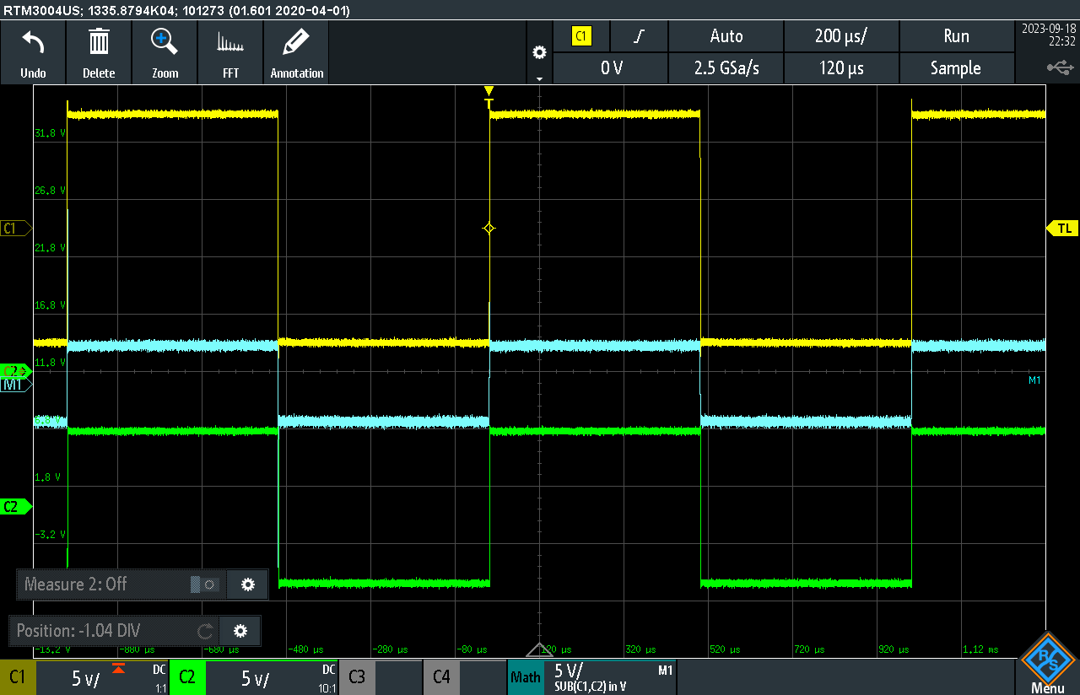

Square Wave

Triangle Wave

# **5.0 Observations and Simulation Comparison**

# Our group successfully assembled all the circuits in this experiment, and this achievement is corroborated by our collected dataset. Our initial circuit was the full-wave rectifier, designed to convert an AC current source into a DC current source. We opted for a full-wave rectifier to mitigate the voltage ripple experienced by the DC load.

# Subsequently, we proceeded to construct a clipping circuit. The unique feature of a clipping circuit lies in its ability to permit one side of an AC waveform while blocking the other. To illustrate, such a circuit allows the upper portion of a sine waveform to pass through while obstructing the lower portion.

# Finally, our last circuit was the clamping circuit. A clamping circuit's behavior involves the output waveform tracking the input waveform until it reaches a specific voltage threshold. Beyond this threshold, the output remains constant, unaffected by variations in the input voltage waveform until it falls below the clipping voltage threshold. In the full-wave rectifier circuit, we had anticipated the presence of some level of ripple in our measurements. Surprisingly, we were unable to discern any ripple in the screenshot of our data. Although voltage ripple indeed existed within the circuit, it proved too minuscule to register on the displayed input and differential voltage waveforms.

# A notable and unexpected phenomenon emerged when examining the clipping circuits. While we had initially expected a straightforward flat-side behavior during clipping, we instead observed a distinct curvature. Our anticipation had been that at the peak of the waveform, we would encounter a voltage drop due to diode losses. However, contrary to our expectations, we found that within the clipped region, the voltage exhibited a slight dip as the input waveform voltage decreased. This intriguing behavior was specific to sine and triangle waveforms, as the square wave exhibited no such characteristics.

# In contrast, the clamping circuits yielded results that impeccably matched both our simulation and hand analysis. Typically, when dealing with non-linear components, there exists a margin of error in hand analysis due to the limitations of mathematical models. However, in this particular experiment, our observations demonstrated that hand analysis proved to be remarkably accurate when compared to other circuit types explored in this study.

# **6.0 Learned Objectives**

* Differential voltage measurements by oscilloscope.
* Clamping Circuit.
* Clipping Circuit.
* Full-wave rectifier.
* Simulation via LT-spice
* Diode performance

# **7.0 Conclusion**

In conclusion, this experiment allowed us to gain valuable insights into the applications and behaviors of diodes in various circuit configurations. We observed the importance of considering non-ideal diode behavior in simulations and the accuracy of hand analysis in clamping circuits. This experience deepened our understanding of electronic circuits and their practical applications.